Lab 4: Add Node Pool

Generate personal access token (PAT)

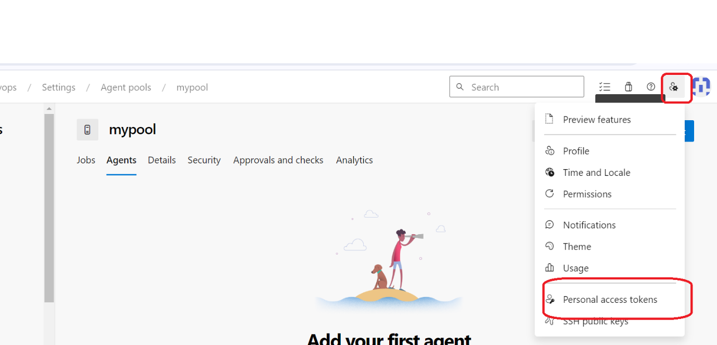

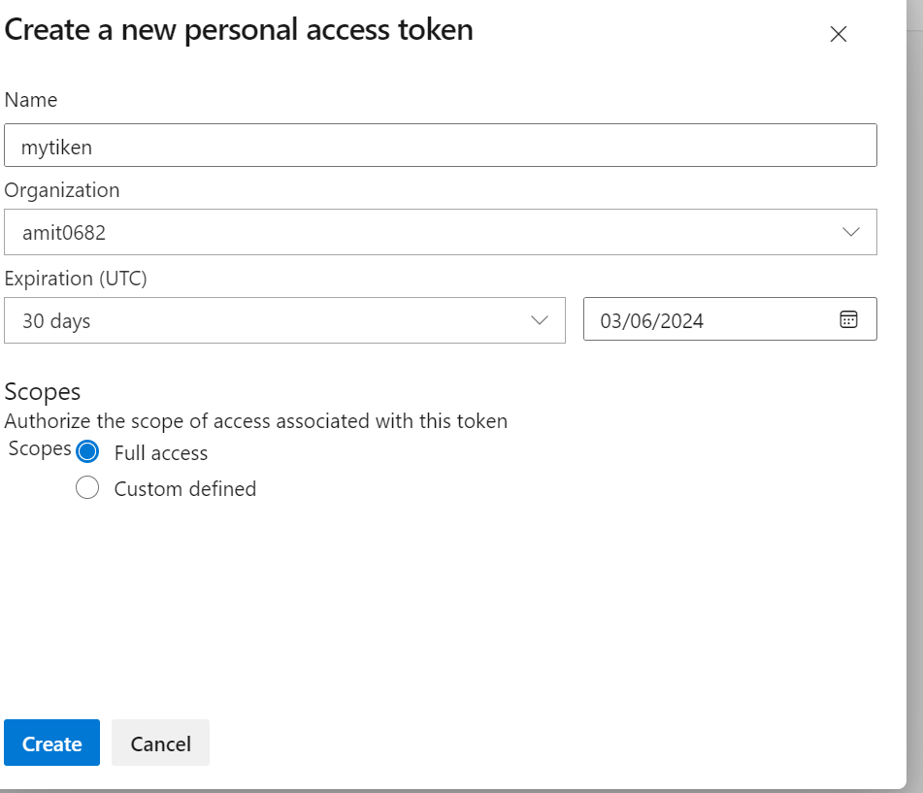

Note down the token

Project->settings

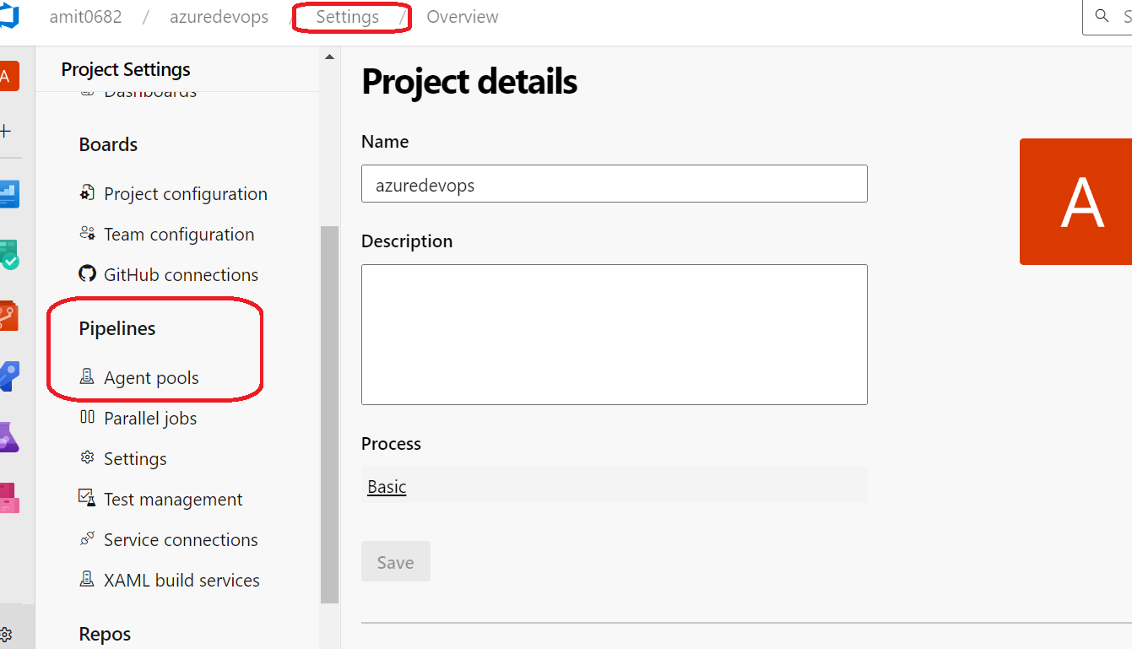

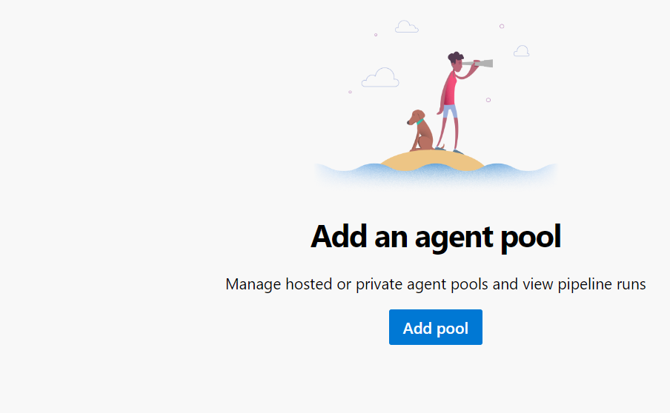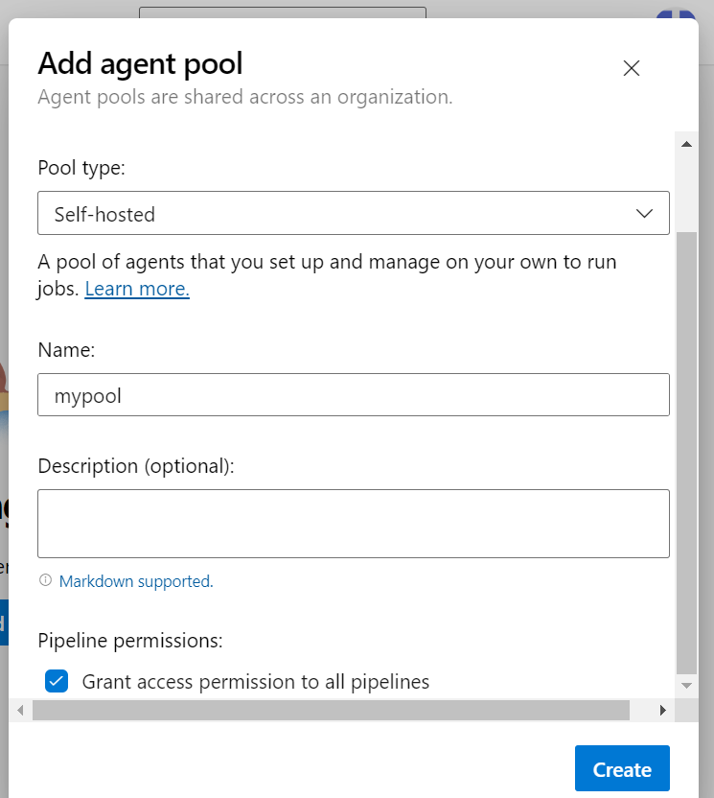

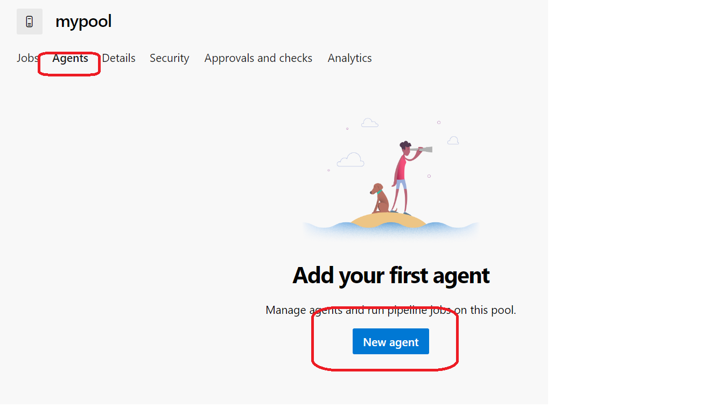

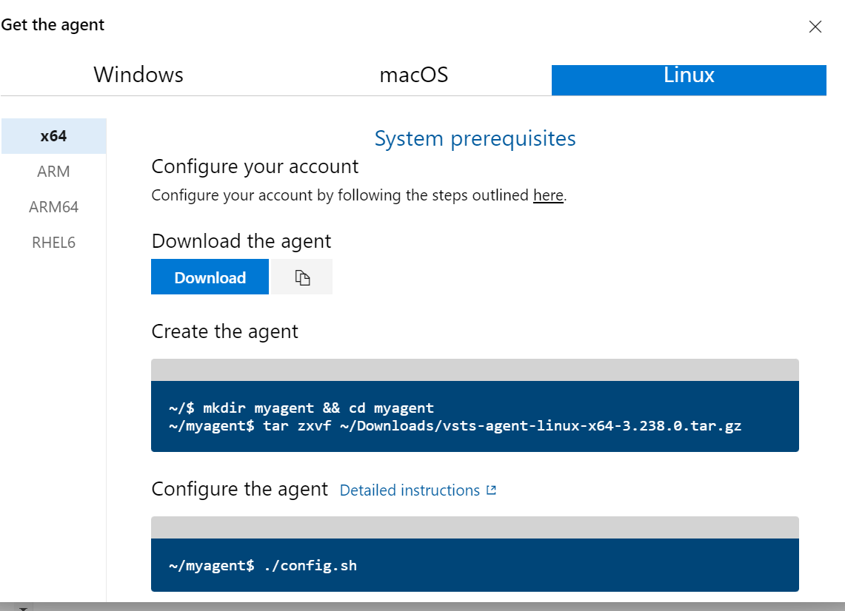

Run on linux vm

wget <https://vstsagentpackage.azureedge.net/agent/3.238.0/vsts-agent-linux-x64-3.238.0.tar.gz>

mkdir myagent

cp vsts-agent-linux-x64-3.238.0.tar.gz myagent/

tar zxvf vsts-agent-linux-x64-3.238.0.tar.gz

Run (non-root user)

1. ./config.sh
2. Provide Url

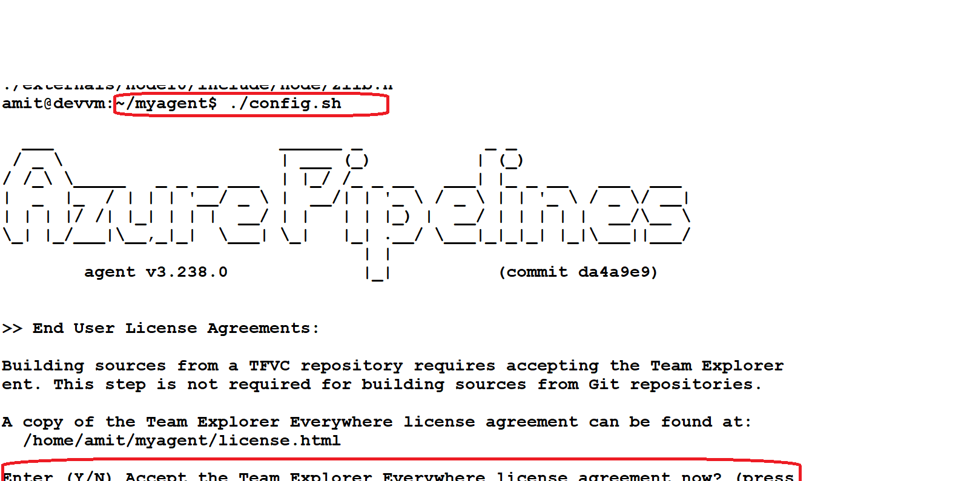

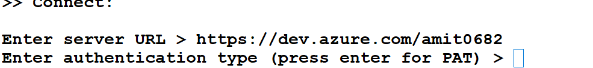

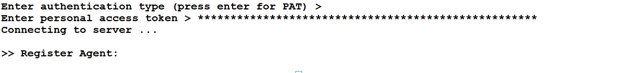

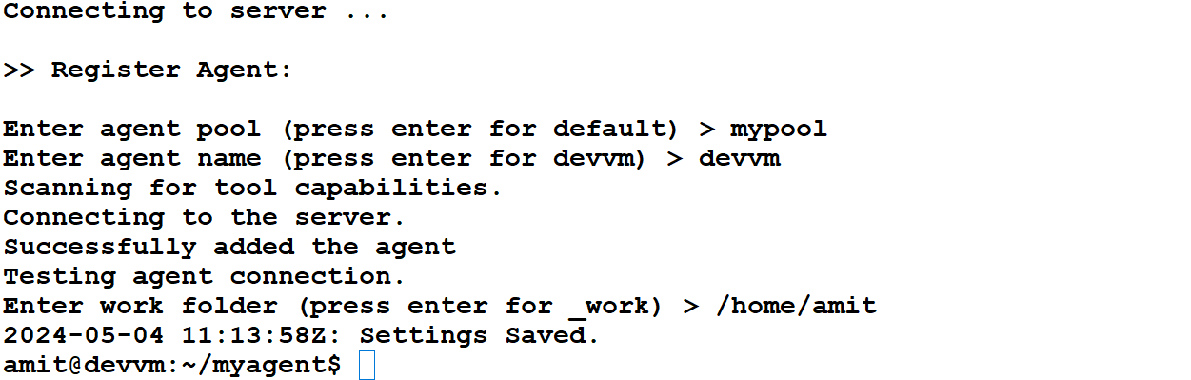

Run the ./run.sh

Show online:

